Microsoft PowerBi

# **Project: Indian Personal Finance and Spending Habits analysis**

**Description**: Dataset contains detailed financial and demographic data for 20,000 individuals, focusing on income, expenses, and potential savings across various categories. The data aims to provide insights into personal financial management and spending patterns.

* **Income & Demographics:**
  + Income: Monthly income in currency units.
  + Age: Age of the individual.
  + Dependents: Number of dependents supported by the individual.
  + Occupation: Type of employment or job role.
  + City_Tier: A categorical variable representing the living area tier (e.g., Tier 1, Tier 2).
* **Monthly Expenses:**
  + Categories like Rent, Loan_Repayment, Insurance, Groceries, Transport, Eating_Out, Entertainment, Utilities, Healthcare, Education, and Miscellaneous record various monthly expenses.
* **Financial Goals & Savings:**
  + Desired Savings Percentage and Desired Savings: Targets for monthly savings.
  + Disposable Income: Income remaining after all expenses are accounted for.
* **Potential Savings:**
  + Includes estimates of potential savings across different spending areas such as Groceries, Transport, Eating_Out, Entertainment, Utilities, Healthcare, Education, and Miscellaneous.
* **Dataset Link:** https://www.kaggle.com/datasets/shriyashjagtap/indian-personal-finance-and-spending-habits

## **Steps I taken in the power query:**

* Initially I **load** the dataset in the power bi.
* Then I do the transformations in **power query** section.
* Making the dataset clean by **Checking duplication, Missing values, Errors** in the dataset.
* In the dataset there is **no unique id** so, I consider all the rows in the dataset.
* After the I set all the **data types** correctly in the power query.
* I had changed the **general numeric data values to currency** (rupees).
* Next steps I used the conditional statement [**Logical**] to know the **High Savings** and **low Savings.**
* Then I used the Dax measures to Total income, Median income [**Statistical Measures**]
* After that I calculated Total Potential Savings by adding all the Potential savings in data
* Personally, I just wanted to know about the people age between 18-20 information about there income and average spending for Eating outside, Average spending for entertainment.
* So, I calculated by using the Dax measures income of **18-20 age** grouped people by using **Calculation function** in that I **sum up the income** using the **filter**, in the **filter I used the comparison operators, AND (&&)** to get the data between the 18-20 age group people.
* Same for the **average of spending eating outside**, just changed to **sum to** **average from income formula**
* Same for the **average of spending entertainment**, just changed to **sum to average from income formula**
* After measures, I used the **group by method** to know about the **distinct** ages, occupation and they income and average income of each age group

## **Creating the report: sheet 1**

**Report image:**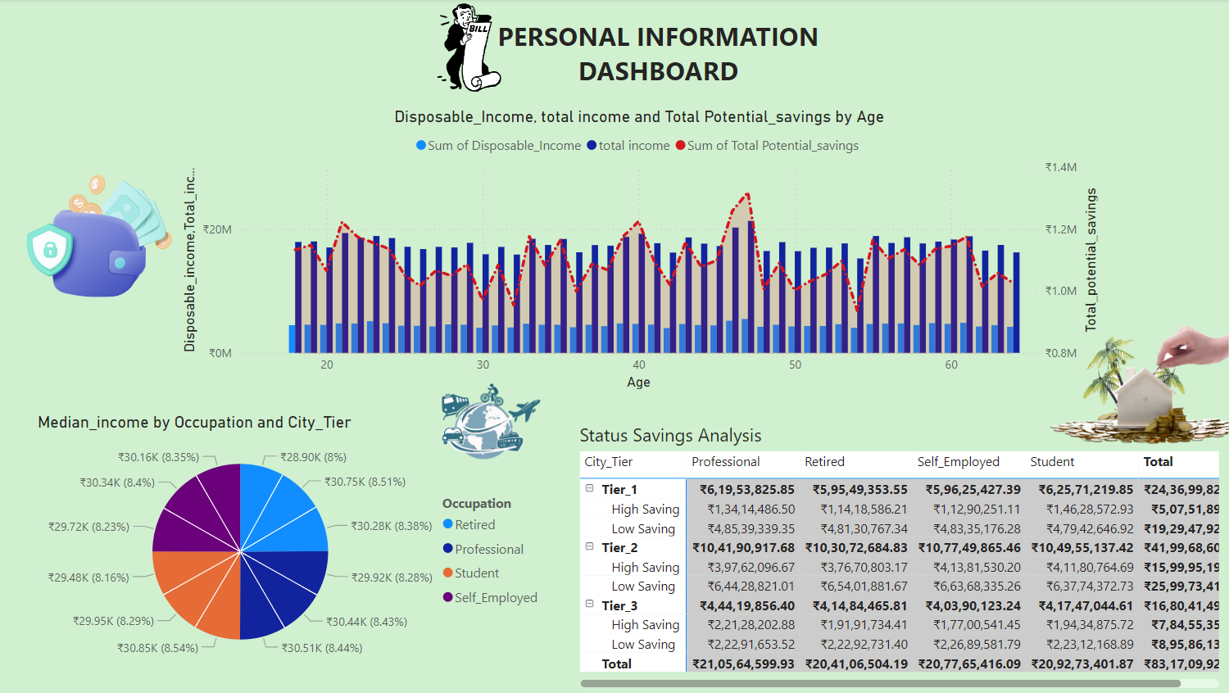

### **Setps to creating the Sheet 1:**

* First, I pick background colour in the report view and searched for the Portable Network Graphics in online
* Then I started creating the report in report view
* First, I used to create the **matrix table** using the city tier and occupations with the status of High Savings and Low Savings
* Then I created a pie chart using the median income by city tier and occupation
* After that, I created a **line and clustered column chart** by using the **x-axis** as age, **column y-axis** as disposable income and total income, **line y-axis as** total potential Savings.
* By using the line clustered column chart, we can know the trends of savings by age groups

#### explanation of sheet 1:

* **Matrix Table:** In the table, I used to insert the city tier column, occupation columns. To the city tier, I insert the status rows and the Total income to know content between them.
* **Pie chart:** It is used know the percentage of each city tier with median income (which means group of people income by number of people), and I used the legend to know the percentage of city tier with occupation
* **Line clustered column chart:**  It is used know about How they are saving money in different ages, and it is helpful to know particular age group are mostly saving the money in age bar

## **Creating the report: sheet 2**

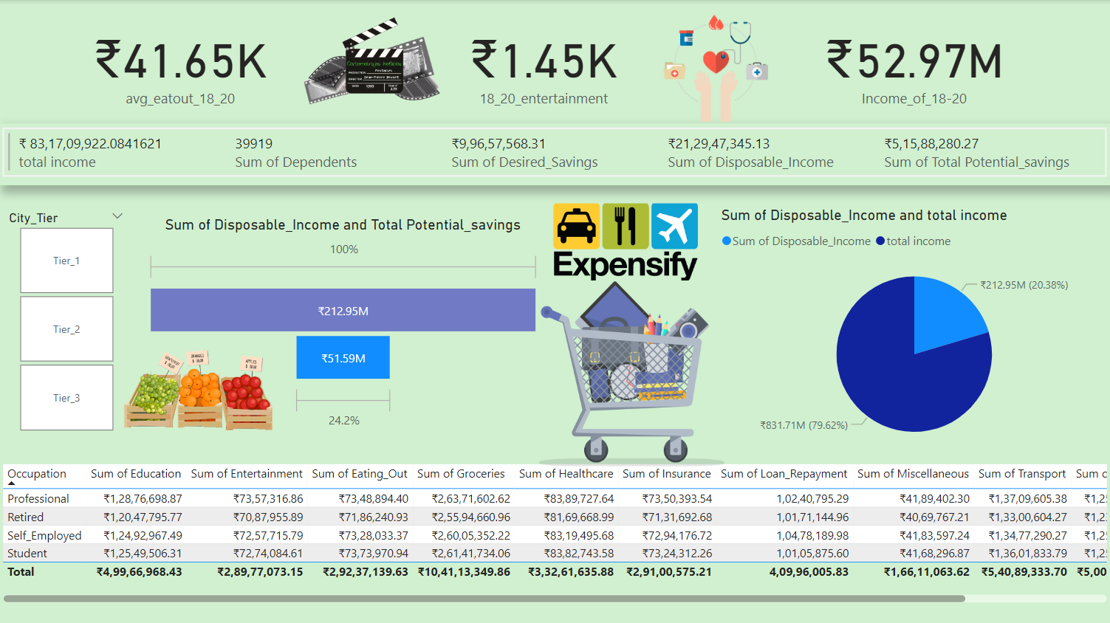**Report image:**

### **Setps to creating the Sheet 2:**

**Income of 18_20 Age:**

* **Card Visual:** Create a card visual to display the total income of 18-20.
* **Measure:** Create a measure to calculate the total income for this age group. You can use DAX to filter and sum the relevant data.

**Average Eat out 18_20 Age:**

* **Card Visual:** Create another card visual to display the average eat out spending for 18-20.
* **Measure:** Create a measure to calculate the average eat out spending using DAX.

**Entertainment 18_20 Age:**

* **Card Visual:** Create a card visual to display the total entertainment spending for 18-20.
* **Measure:** Create a measure to calculate the total entertainment spending using DAX.

**Pie Chart:**

* **Pie Chart Visual:** Create a pie chart to visualize the distribution of disposable income and total income.
* **Measures:** Use the same measures for disposable income and total income as used in the previous calculations.

**Funnel:**

* **Funnel:** Create a Funnel to visualize the disposable income which is also called as remaining amount and total potential savings to know percentage of savings in potentially and the percentage of the remaining amount after the all the expenditure.
* **Measures:** Use the same measures for disposable income and total potential savings as used in the previous calculations.

**Table Visual:**

* **Table Visual:** Create a table to show the breakdown of expenses by occupation and category.
* **Measures:** Use measures to calculate the sum of each expense category for each occupation.